GERIATRIC SOCIETY OF INDIA”
A2-007, Palm Resort, Raj Nagar Extension, Ghaziabad, Uttar Pradesh - 201017
E-mail: opsharma.gsi@gmail.com , info@geriatricindia.in Visit us at : http://www.geriatricindia.com

MEMBERSHIP FORM

I wish to join Geriatric Society of India as Life / Ordinary member and promise to abide by its rules and regulations
Full Name (block letters).................................................................................................................. Age..............M/F...
Qualification (with year & university)..................................................................................................................
Residential Address......................................................................................................................................
. Tel.
Office Address with designation
. Tel.
Email ..................................................................................................................................................

Category of Membership (Please tick one): Specialist / Family Physician / Non Medical (above 60 years only)

Life Membership fee
- National Individual Rs. 8,000/-
- National Institutional Rs. 15,000/-
- Overseas Individual USD 250 Associate Membership Fees (Without voting right)
- AYUSH Rs. 5,000/-
- Nurses / Physiotherapist Rs. 4,0001-
Scan & Pay

Bank Details :- Account Name - Geriatric Society of India, Account No. 408260693 IFSC Code - IDIB000H019, Account Type - Savings
Pay by UPI ID - 9560042237@indianbnk

Proposed by
Name ..........................................................................................

Address ......................................................................................

Membership No
Seconded by Name ...................................................

Address

Membership No.

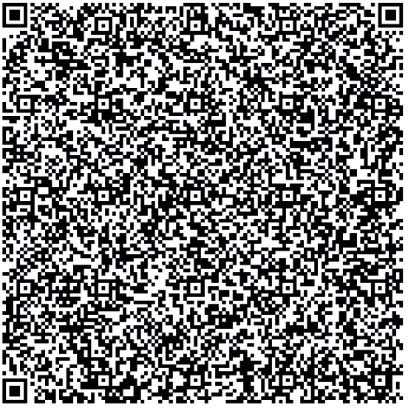
Note: In the absence of availability of proposer and seconded please send the following:
- A photocopy of Degree
- Photocopy of registration by relevant Medical Council
- In case of non-medical member proposer and seconded are essential.

For Official Use

Membership No. Signature of Honorary Secretary

